**Week#5**

**Domain Name System Simulation**

**Learning objectives:**

A. Learn to set up DNS.

B. validate your theoretical concepts on how DNS works.

C. learn about DNS resource record types

**This session has 2 parts**

**1. Create a network with one DNS server and Web server and browse.**

**2. Add an authoritative server and analyse how DNS works.**

**Part 1. Create the topology as below:**

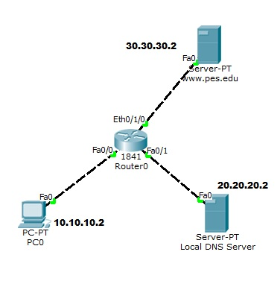

**Real Time Mode**

|  |  |  |
| --- | --- | --- |
|  | **Action** | **Observation** |
| 1 | Create the topology as shown that comprises :   1. Client PC 2. Web server www.pes.edu 3. Local DNS Server |  |
| 2 | Configure IP addresses as shown |  |
| 4 | Configure DNS Servers as follows |  |
|  | DNS Server#1: Local   |  |  |  | | --- | --- | --- | | Name | Type | IP address | | www.pes.edu | A Record | 30.30.30.2 | |  |
| 4 | HTTP Server  Edit the html page :  “ Welcome to PES University” |  |
| 5 | Select Client PC  Select Configuration  Select Desktop  Select Web Browser  Enter URL : www.pes.edu | **html page :** |

**Simulation Mode**

**[ Before selecting Simulation mode , clear the cache of the DNS server;**

**To clear cache, Click the respective DNS server, click configuration, click DNS , Click DNS cache and click clear cache ]**

|  |  |  |
| --- | --- | --- |
|  | **Action** | **Observation** |
| 1 | Repeat browsing |  |
| 2 | In the event list filter all protocols and select only DNS |  |
| 3 | Click Auto Capture mode and wait until the html page is displayed | Write down your observation |

**Part 2: Create the topology as below**

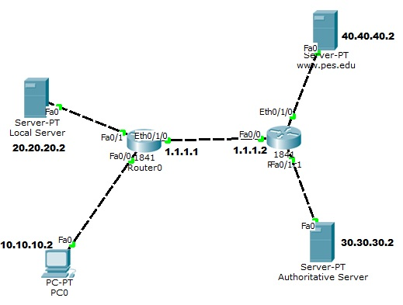

|  |  |  |
| --- | --- | --- |
|  | **Action** | **Observation** |
| 1 | Create the topology as shown that comprises :   1. Client PC 2. Web server www.pes.edu 3. Local DNS Server 4. Authoritative DNS server |  |
| 2 | Configure IP addresses as shown |  |
| 3 | **Configure in the client, DNS server address as 20.20.20.2 ( which is the IP address of local DNS )** |  |
| 4 | Configure DNS Servers as follows |  |
|  | DNS Server#1: Local   |  |  |  | | --- | --- | --- | | Name | Type | IP address | | Authoritative | A | 30.30.30.2 | | www.pes.edu | NS | Authoritative | |  |
|  | DNS Server#2: Authoritative   |  |  |  | | --- | --- | --- | | Name | Type | IP address | | www.pes.edu | A | 40.40.40.2 | |  |
| 4 | Repeat browsing in real mode | Write down your observation |
| 5 | Repeat browsing in simulation mode | Write down your observation |